
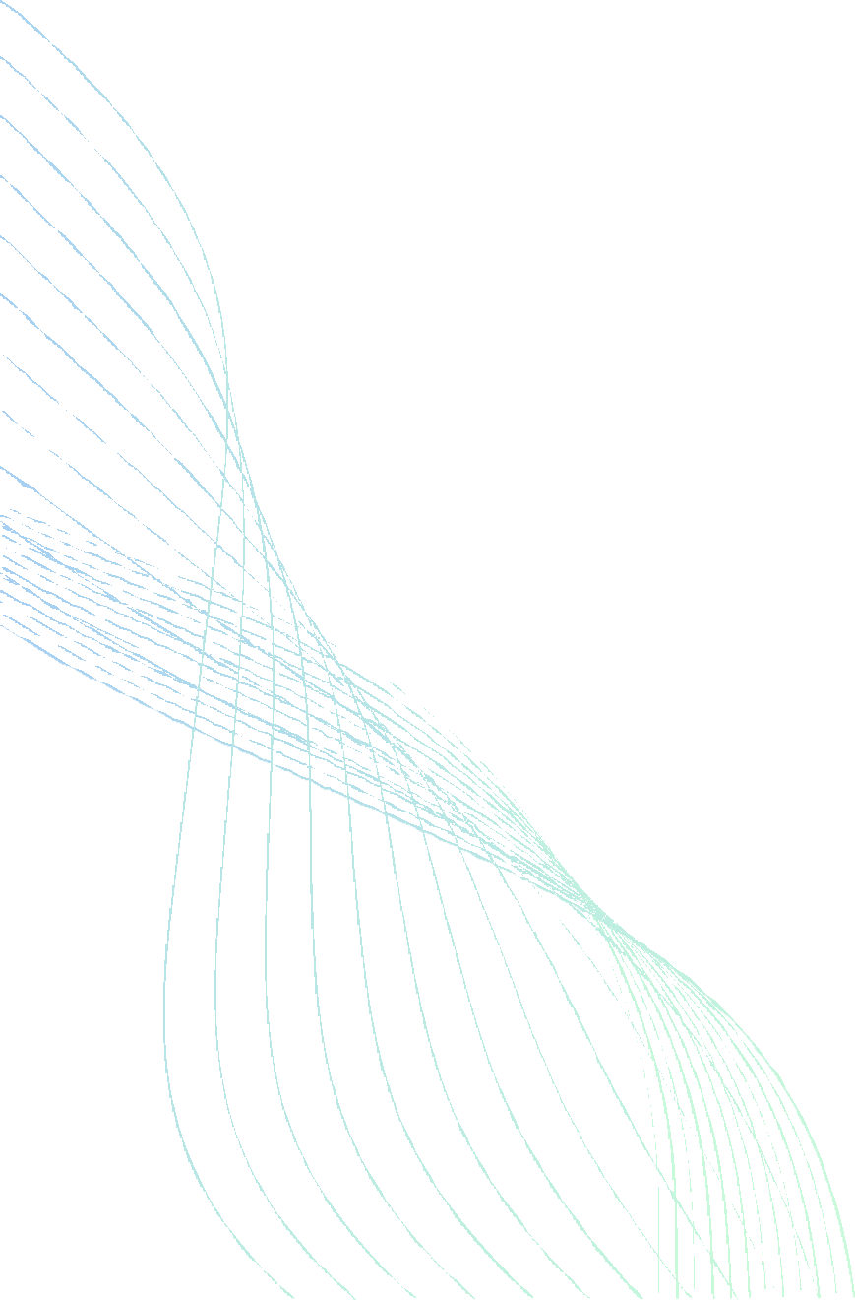

DIGITAL FARM MANAGEMENT SYSTEM

FINAL
REPORT

PRESENTED TO
MS BUSHRA MEHMOOD

PRESENTED BY
MUHAMMAD NOMAN 42124
MUHAMMAD ILLYAS 42105
HAMZA SIDDIQUE 39912

Final Report OOP

1. Introduction

1.1 Project Overview
This project simulates a digital farm management system where users can:
- Manage livestock (cows and chickens) with health and feeding mechanics.
- Cultivate crops (wheat and corn) with growth cycles and harvest yields.
- Assign workers (animal caretakers and field workers) to automate tasks.
- Engage in a dynamic market to buy/sell farm products.

1.2 Objectives
The objective of this project was to develop a Digital Farm Management System using C++ with both a console-based interface and a Graphical User Interface (GUI). The system simulates farm operations, including livestock management, crop cultivation, worker assignments, and market transactions. The GUI enhances user interaction by providing a visual and intuitive way to manage the farm, making the system more accessible and engaging.
- Demonstrate object-oriented programming (OOP) principles in Python.
- Build an interactive Streamlit GUI for user-friendly farm management.
- Simulate real-world farm economics (supply/demand, health decay).

2. Problem Solution
Managing a farm involves tracking multiple tasks, such as feeding animals, monitoring crop growth, and handling finances. A text-based system works functionally but lacks user-friendliness.
This project solves these challenges by:
- Providing two interfaces:
  - Console-based for functionality and debugging.
  - GUI-based for better visualization and ease of use.
- Automating farm operations (animal health, crop cycles, market trading).
- Using OOP principles to ensure modularity and scalability.
The GUI improves accessibility, making the system suitable for users who prefer visual interaction over command-line inputs.

3. Features

1. Core Functionality (Console & GUI)
- Animal Management
  - Add/remove cows and chickens.
  - Feed animals and check health status.
  - Collect milk and eggs.
- Crop Management
  - Plant and harvest wheat/corn.
  - Water crops and track growth.
- Worker System
  - Assign caretakers for animals and field workers for crops.
  - Manage and perform tasks for animals and crops
- Market Simulation
  - Buy/sell goods with dynamic pricing.

2. GUI-Specific Features
- Visual Dashboard
  - Real-time updates on animal health, crop status, and inventory.
- Interactive Buttons & Menus
  - Simplified navigation (no manual command typing).
- Graphical Representations
  - Progress bars for crop growth, animal health.
  - Icons for animals, crops, and resources.
- Notifications
  - Alerts for low health, unwatered crops, or harvest readiness.

4. OOP Concepts Implemented
1. Inheritance
The Animal and Crop base classes provide shared attributes, while Cow, Chicken, Wheat, and Corn implement specialized behaviors. This eliminates code duplication when adding new farm entities.

2. Polymorphism
The feed() and produce() methods behave differently per animal type. Calling these on generic Animal objects automatically selects the correct implementation, enabling flexible farm operations.
3. Encapsulation
Critical data like health and milk_capacity are managed through controlled methods. Static variables track inventory securely, preventing direct external access that could corrupt game state.
4. Abstraction
Abstract methods like grow() enforce implementation rules while hiding complex logic. Users interact with simple commands ("feed", "harvest") without needing backend knowledge.
5. Static Members
Cow.milk_capacity and Chicken.totalEggs provide global inventory tracking. These persist across all instances and sync automatically with the Streamlit UI.
Concept Synergy
Polymorphism enables the WorkerManager to handle animals generically, while encapsulation protects data during GUI interactions. Static variables maintain real-time inventory updates across the system.

5. Code

1. Base Classes:
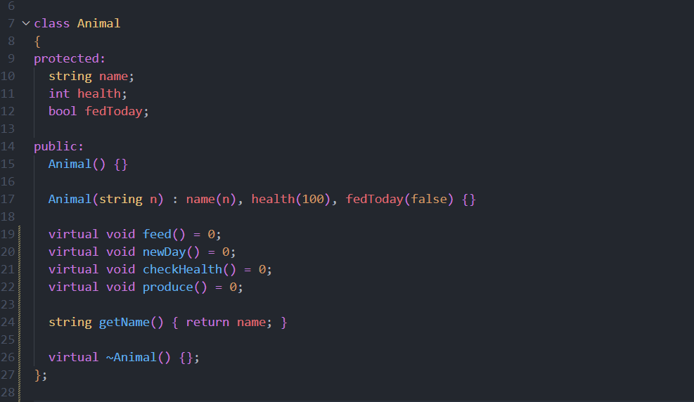

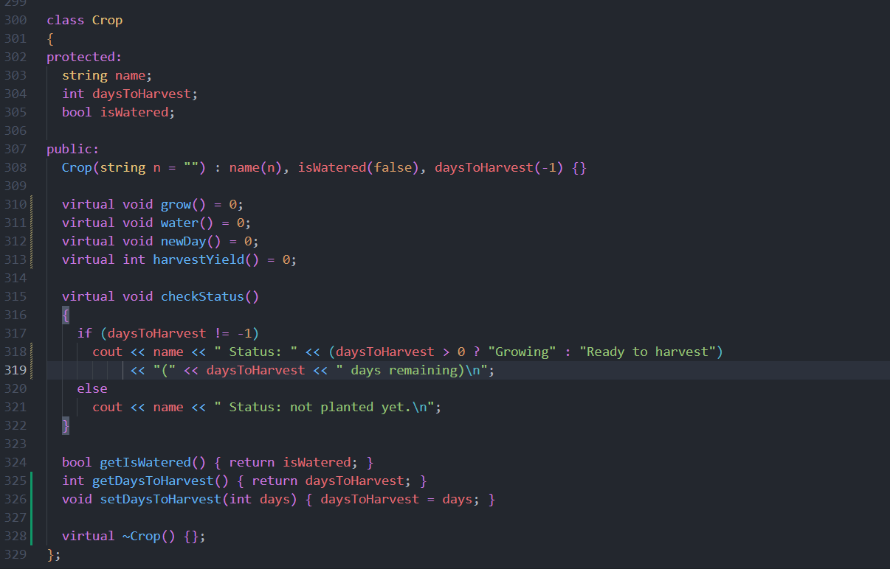

2. Derived Classes
First we’ll start with overridden methods of derived classes
Below is the code of Cow child class
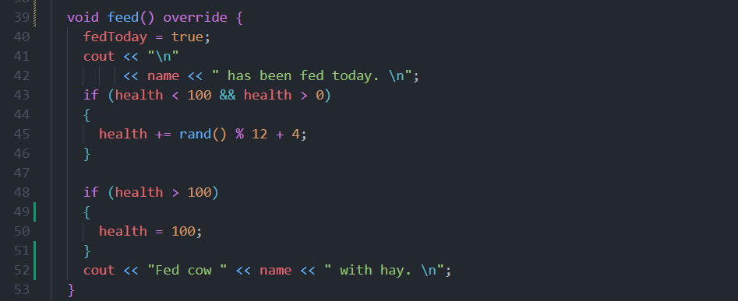

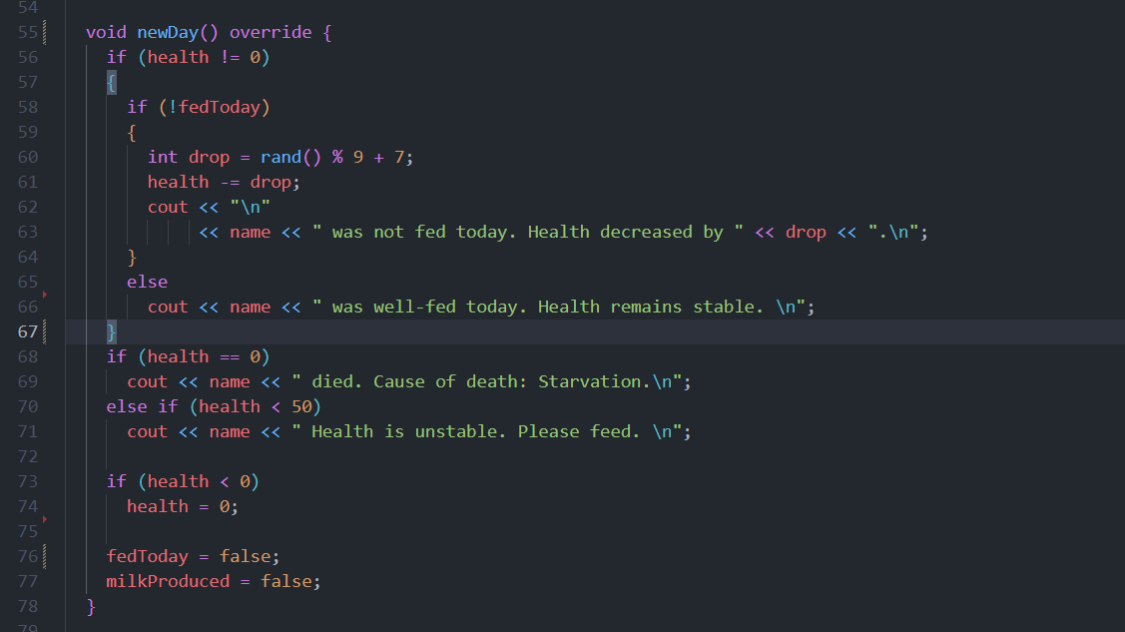

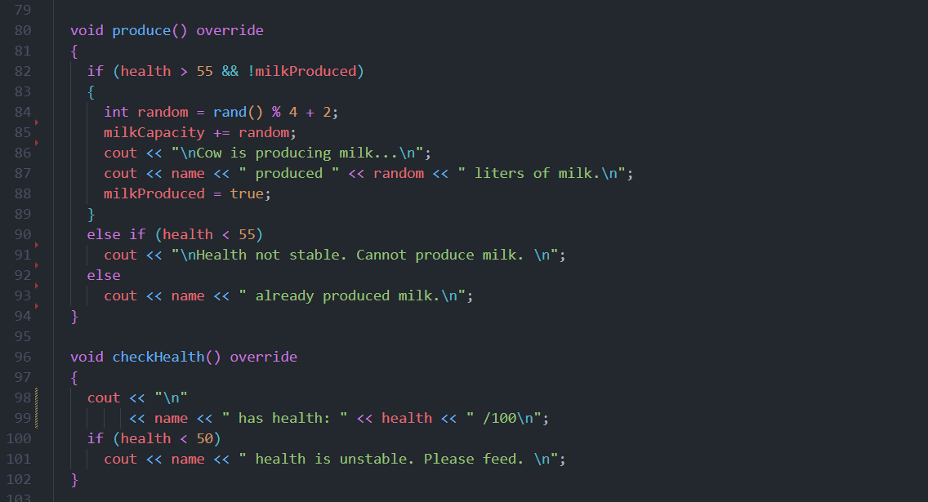

Similarly now the code for the crop derive class
Below is the code of Wheat child class overridden methods

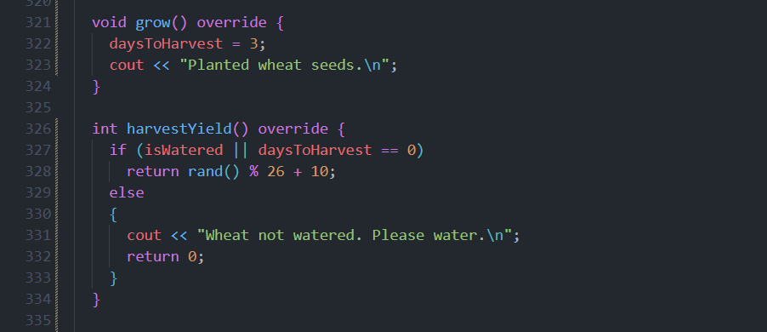

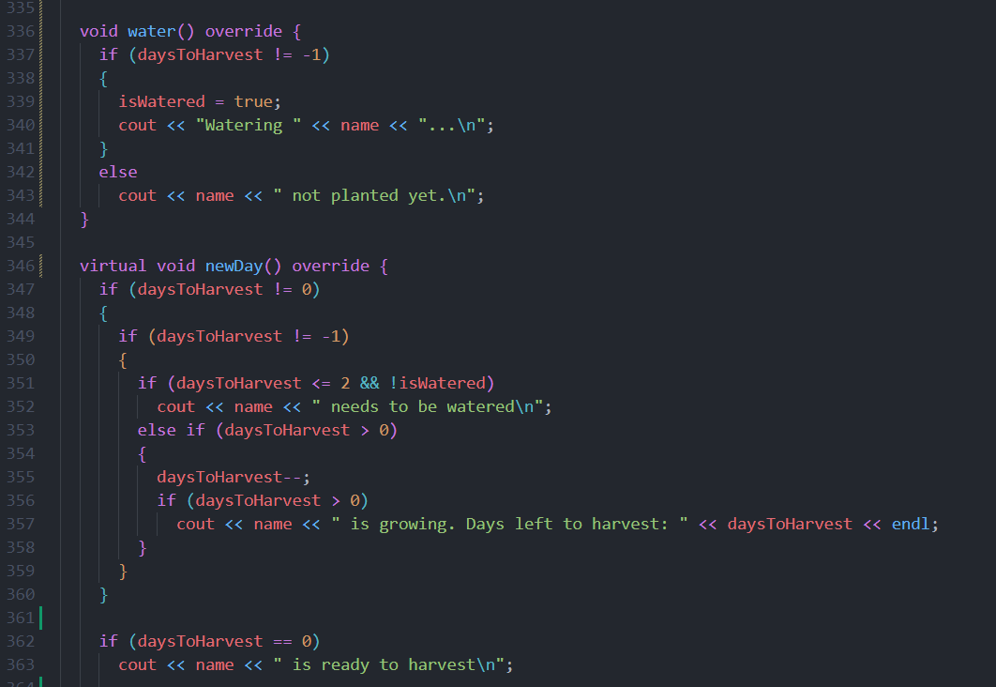

Variables (including static too) and objects

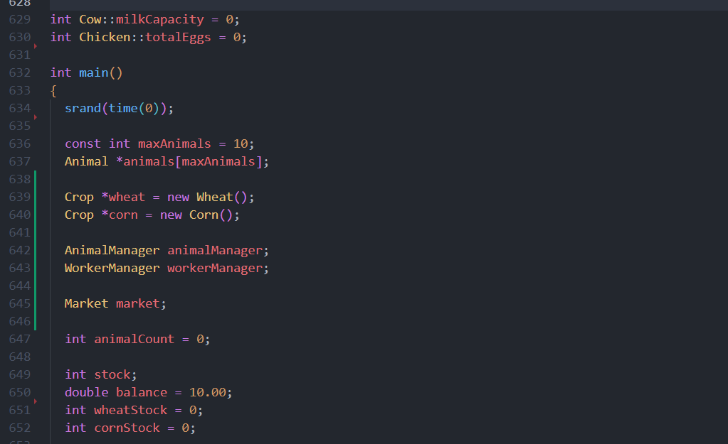

6. Code + Output:

